Mini Mock Hearing: Must I Wear a Mask in School? High School Version. 3 persons. By Richard L. Roe

Facts. Metro City has 3 high schools like Mandela HS. Mandela HS has 1200 students ages 14-18. Metro City was hit hard by COVID-19. Schools were closed to avoid spreading COVID. Now schools are reopening. Parents, teachers and children want the schools to be safe. All people in the school has to do their part to prevent COVID-19. Chris, a 17 year old student at MHS, went to school on the first day wearing a mask. Inside MHS, after an hour Chris had trouble breathing. Chris removed the mask. Principal Jones sent Chris home. Principal Jones said that Chris could not return to school unless Chris wore the mask according to the rules.

Rule. Metro City’s Superintendent of Schools, Dr. Smith, the head of Metro City’s public schools, made a rule for all schools. This is the rule:
Inside the schools, everyone - teachers, students, parents and visitors – must
wear a mask covering nose to chin at all times, stay 6 feet from others, and wash hands often. Outside the school building, masks are not needed when 10 or more feet from others.
“When you wear a mask, your mask protects me. My mask protects you. That’s why everyone has to wear a mask.”

Next Steps. Chris appealed Principal Jones’s decision to Dr. Smith. Chris is asking Dr. Smith to make an exception to the rule in the situation of Chris and other children like Chris. Dr. Smith will conduct an informal hearing, where Chris and Principal Jones will present their sides of the disagreement. Dr. Smith will then make a decision.

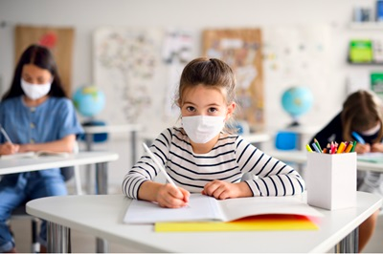
Exhibit #1, Students in a Metro City school on first day of school reopening.

Chris’s story: I am 17 years old. I attend Mandela HS. I have asthma, an illness that makes it hard for me to breathe. When I went to school the first day, I wore my mask. After an hour I could not breathe well. I started getting dizzy. I took of my mask. Principal Jones saw me without a mask and sent me home.
I don’t want to make other people sick. I like school and want to attend school. I want to learn just like my friends. I am a good student, with top grades. In science class the first day, I saw a video about COVID-19. It showed that without a mask, a sick person’s breathing sends germs out a few feet. Coughing makes the germs go farther. Masks stop or slow down most of the germs so they don’t go far. They also protect the wearer from other people’s germs.

The mask makes it harder for me to breathe. After about an hour, I sometimes feel I don’t have enough air. I start getting dizzy. I don’t have to wear a mask outside the building when I am by myself. I feel better then. If I could leave the school building for a few minutes to breathe air without a mask when I feel dizzy, I would be okay. Although I like to hang out with my friends, we know about social distancing. I can stay ten feet away from everyone and still have a good time. And when I need to go outside to breathe better, I can stay by myself until I feel better.

Exhibit #2: Photo of person sneezing, breathing out water droplets, in research study.

Principal Jones’s story: Chris is an outstanding student. We want to have Chris in MHS. But we can’t risk Chris spreading coronavirus and COVID-19 to others in the school. As principal, I have to follow the rules.
Everyone who comes into the school needs to wear a mask. COVID-19 is spread by infected people breathing out the COVID germs. Their breath can infect people close to them and a few feet away. That’s because there are 2 steps to becoming sick with COVID. The first is getting the COVID germs and becoming infected. The germs grow and spread inside the infected person for a few days or even longer before the infected person feels sick. S/he gets either headaches, body aches, or fever, or all 3. Also not being able to taste or smell. But all during these first few days, before showing signs of being sick, an infected person can spread COVID to others nearby. And some infected people never look or feel sick. But they can still give COVID to others.
It’s difficult to get the students to maintain social distance in the classrooms and on the playground. They have a tendency to get close to each other, closer that the rules and good health practices require. We can’t monitor Chris’s behavior all the time to see that Chris maintains social distance without a mask, especially if Chris leaves the building on his/her own.
It’s important for all people in the school to wear masks at all times. If I give an exception to one student, I have to give exceptions to others. For example, two students said they have already been infected with COVID-19 two months ago. They tested positive for antibodies to COVID-19 and feel they are no longer contagious and a test then showed antibodies. But the research isn’t clear on how long antibodies last. They could get sick again, as one teenager did. It was in the news. I don’t have the time or the expertise to make these kinds of decisions.
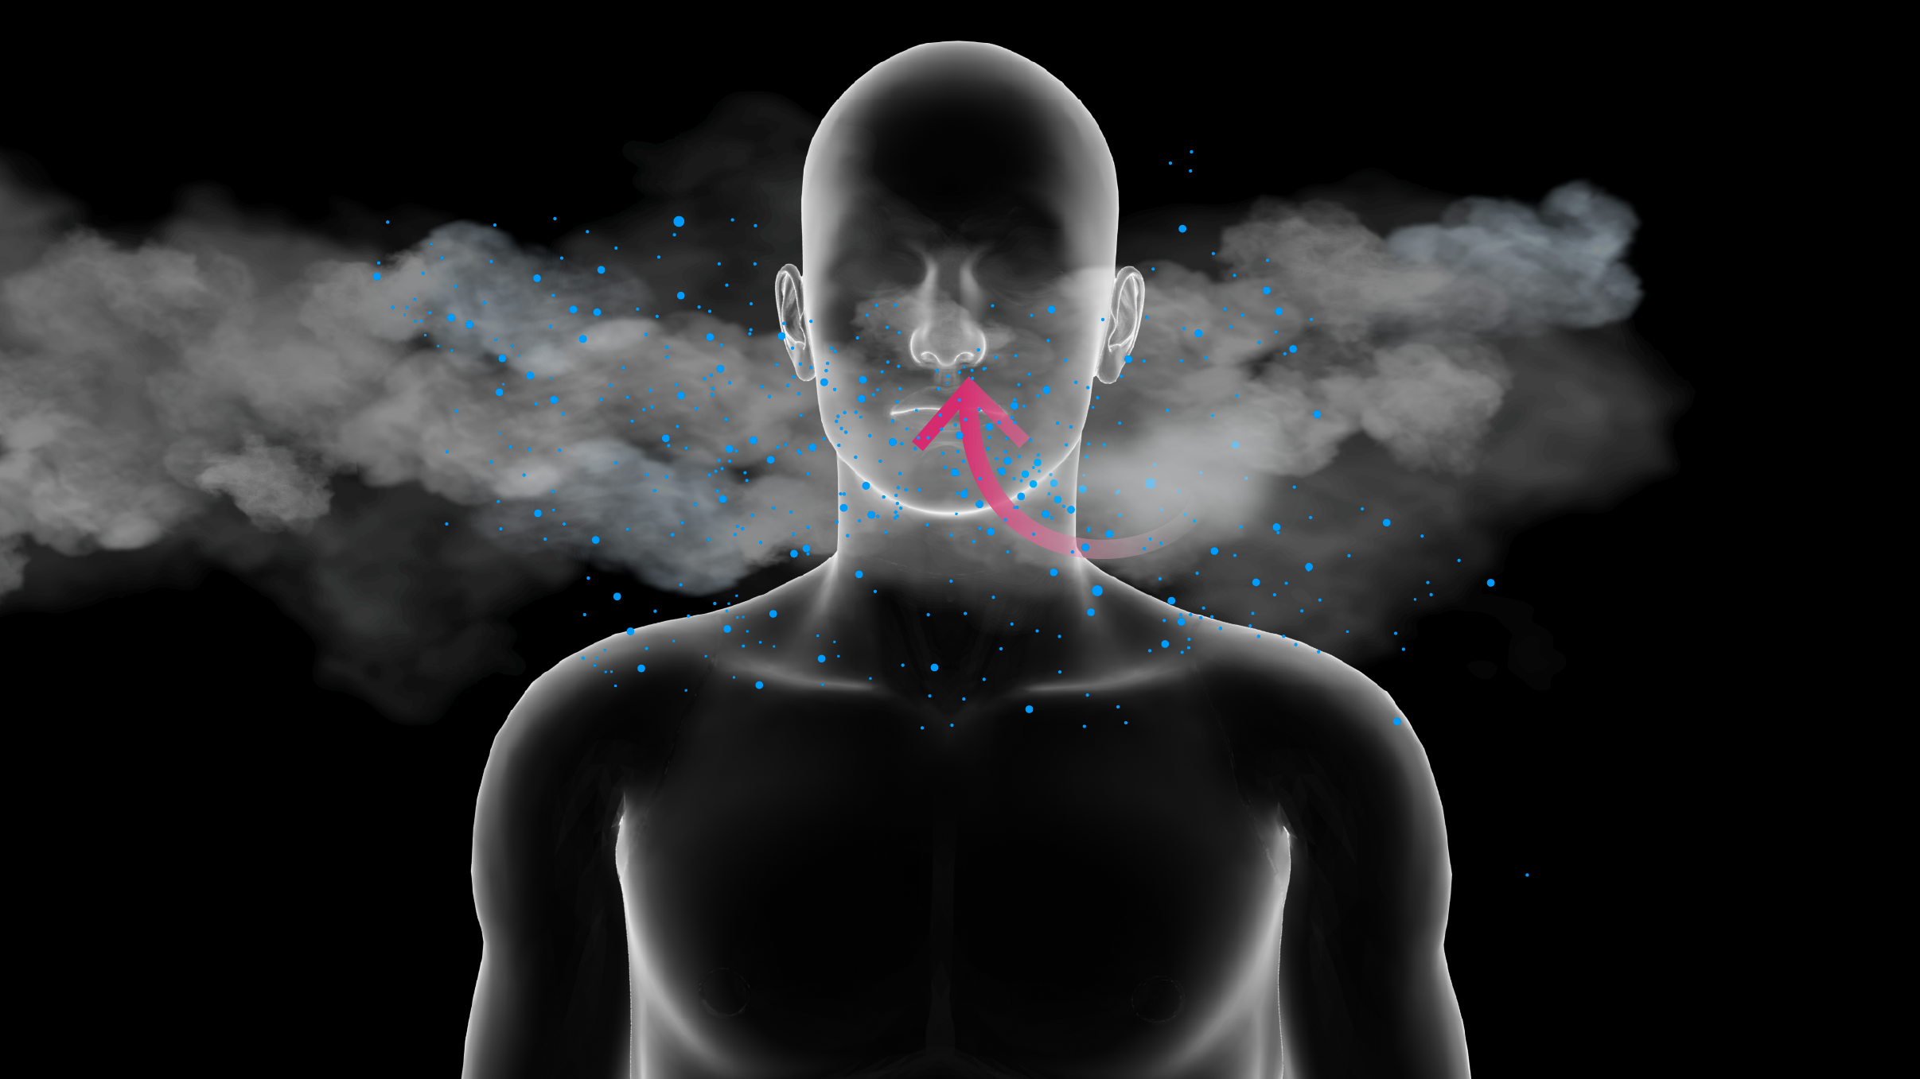
Exhibit #3. Photo from research showing droplets (blue) and water vapor in a cloud in ordinary breathing.
Preparation: The trials will be enacted in groups of 3. Each hearing group will have one parent, one principal and one or more Dr. Smiths. These groups spread out and conduct the hearings at the same time.
1. The whole class first divides into 3 equal groups: #1, Chris or Chris’s parent, #2, Principal Jones, #3 Dr. Smith. If the number of participants is not equally divisible by 3, the extra people join Group #3, Dr. Smith. These 3 groups have 10-15 minutes to prepare for the hearing, helping each other with ideas how to present their cases and roles and what questions to ask.
2. To get into groups of 3, participants subdivide again. Count off from 1 to the number of people in the groups. The three #1’s from each group will form hearing group #1, the three #2’s form hearing group #2, and so on. The hearings should be conducted in the following steps:

Procedure for the hearing. Dr. Smith serves as judge and can ask questions throughout.
Opening statement: Chris (1 min)
Principal Jones (1 min)

Chris’s presents his/her case: Chris (3 minutes)
Principal Jones asks questions to Parent: Principal Jones (2 minutes)

Principal Jones presents case: Principal Jones (3 minutes)
Chris asks questions to Principal: Chris (2 minutes)

Closing summary: Chris (2 minutes)
Principal Jones (2 minutes)

Dr. Smith states his/her decision Dr. Smith (Do this as a whole class; then discussion)

